



Semisubmersible Rig Mooring Feasibility

Mooring Analysis

June 17, 2016

|  |  |  |  |  |  |
| --- | --- | --- | --- | --- | --- |
| Rev | Description | Date | Author | Reviewer | Approver |
| 01 | New Document | 6June 16 | VD | MP | VA |
| 02 | Added results |  | VD | MP | VA |
|  |  |  |  |  |  |

Revision History

|  |  |  |  |
| --- | --- | --- | --- |
| Rev | Description | Section | Pages |
| 01 | New document | - | - |
|  |  |  |  |
|  |  |  |  |

CONTENTS

1 Introduction 3

2 Abbrevations ands definitions 3

3 Design Basis 3

3.1 Codes and Standards 3

3.2 Water Depth 4

3.3 Environmental Data 4

4 Vessel Data 5

4.1.1 RAO data 6

4.2 Force coefficients 9

5 Water Depth 13

6 Mooring Configuration 14

6.1.1 Mooring system arrangement in particulates: 14

6.1.2 Vessel Position, 100 yr Hurricane Condition, 8 Point Intact Moorings, Configuration 4 16

6.1.3 Vessel Position, 100 yr Hurricane Condition, 12 Point Intact Moorings, Configuration 4 16

6.1.4 8 Point Mooring System, Effective Tension for Highest Tension Mooring Line-6, Configuration 4 17

6.1.5 8 Point Mooring System, Effective Tension for Lowest Tension Mooring Line-1, Configuration 17

6.1.6 12 Point Mooring System Effective Tension for Highest Tension Mooring Line-8, Configuration 4 18

6.1.7 12 Point Mooring System, Effective Tension for Lowest Tension Mooring Line-1, Configuration 4 19

6.1.8 Mooring System 19

6.2 Mooring Properties 20

7 Riser data 21

7.1 Riser Configuration Summary 22

7.2 Riser Stroke, 100 year Hurricane, Intact Mooring 23

8 Analysis Methodology 26

8.1 Design Criteria 27

8.1.1 Tension Safety Factors 27

8.1.2 Anchor Uplift Angles 27

8.1.3 Configuration Criteria 27

9 Riser stretch analysis 28

9.1 Design Criteria 28

9.2 Analysis Methodology 28

10 References 31

Appendix A - Vessel Data Dimensions 31

Appendix C - Vessel Hull Dimensions 34

# Introduction

A semisubmersible drilling vessel is being considered to be moored in 6000 ft water depth in Central Gulf of Mexico. Mooring analysis is to be conducted assuming an 8 point and 12 point polyester mooring for this study.to determine feasibility.

A part of this study, the main objectives are as follows:

* Minimize the lateral offset (preferably to 4% in 100 year hurricane) with in practical levels
* Determine the approximate stroke requirements for a typical 22 inch riser with 1.4 wall thickness.

Key analysis assumptions are:

* Chain-polyester-chain configuration
* 8 point mooring and 12 point mooring.
* 100 year hurricane loading at 45 deg to surge axis
* Only Intact moorings analysis is conducted

# Abbrevations ands definitions

API – American petroleum Institute

CG – Centre of Gravity

DR - Drilling Riser

SEMI- Semisubmersible

SK-Station Keeping

GoM -Gulf of Mexico

Ft- Feet

# Design Basis

Analysis is conducted assuming an 8point and 12point polyester mooring for 100 year hurricane loading conditions. The design data used for the analysis is given in this section

## Codes and Standards

The codes referred in this report and their usage is summarized in Table 1.

|  |  |  |
| --- | --- | --- |
| **Code** | **Usage** | **Reference** |
| API RP 2SK | Mooring system design criteria | [1] |
| API-RP-2I | Ropes and integrity? | [2] |
| API-RP-2MET | Generic Metocean data for analysis |  |

Table 1 – Codes and Usage

## Water Depth

The water depth used for the analysis is 6000 ft(1828m). No tidal variation is considered for this analysis.

## Environmental Data

Environmental conditions:

10 yr and 100yr winter storm (with associated current)

10 yr and 100yr hurricane (with associated current)

10 yr and 100yr loop current conditions (with associated wave)

The 100 year hurricane wave and associated current data used for the analysis is given in this section. The central GoM data will be used for analysis.

|  |  |  |  |
| --- | --- | --- | --- |
| **100 year Hurricane** | | | |
| **Description** | **Unit** | **Central GoM** | **Western GoM** |
| **Wind Speed , Ws** | m/s | 54.5 | 54.5 |
| **Significant wave height, Hs** | m | 15.8 | 14.0 |
| **Maximum Wave Height, Hmax** | m | 27.9 | 24.7 |
| **Maximum Crest Elevation** | m | 18.1 | 159.9 |
| **Peak Spectral Period, TP** | s | 15.4 | 15.2 |
| **Associated Maximum period, Tmax** | s | 13.9 | 13.7 |
| **Wave Type** | - | Jonswap | |

Table 2 – 100 Year Hurricane Data

|  |  |  |
| --- | --- | --- |
| **100 yr Hurricane - Associated Current** | | |
| **Water Depth (ft)** | **Current Speed (knots)** | |
| **Central GoM** | **Western GoM** |
| 0 | 4.7 | 3.9 |
| 328 | 4.7 | 3.9 |
| 3000 | 3.2 | 2.9 |
| 5672 | 0.6 | 0.6 |
| 6000 | 0.0 | 0.0 |

Table 3 – Current Associated with 100 yr Hurricane

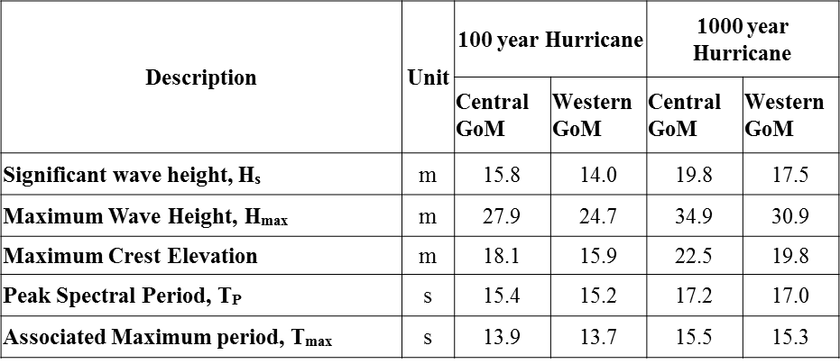

Table 4 – Current Associated with 100 yr & 1000 yr Hurricane

# Vessel Data

The vessel data used for the analysis is given in the following subsections

### RAO data

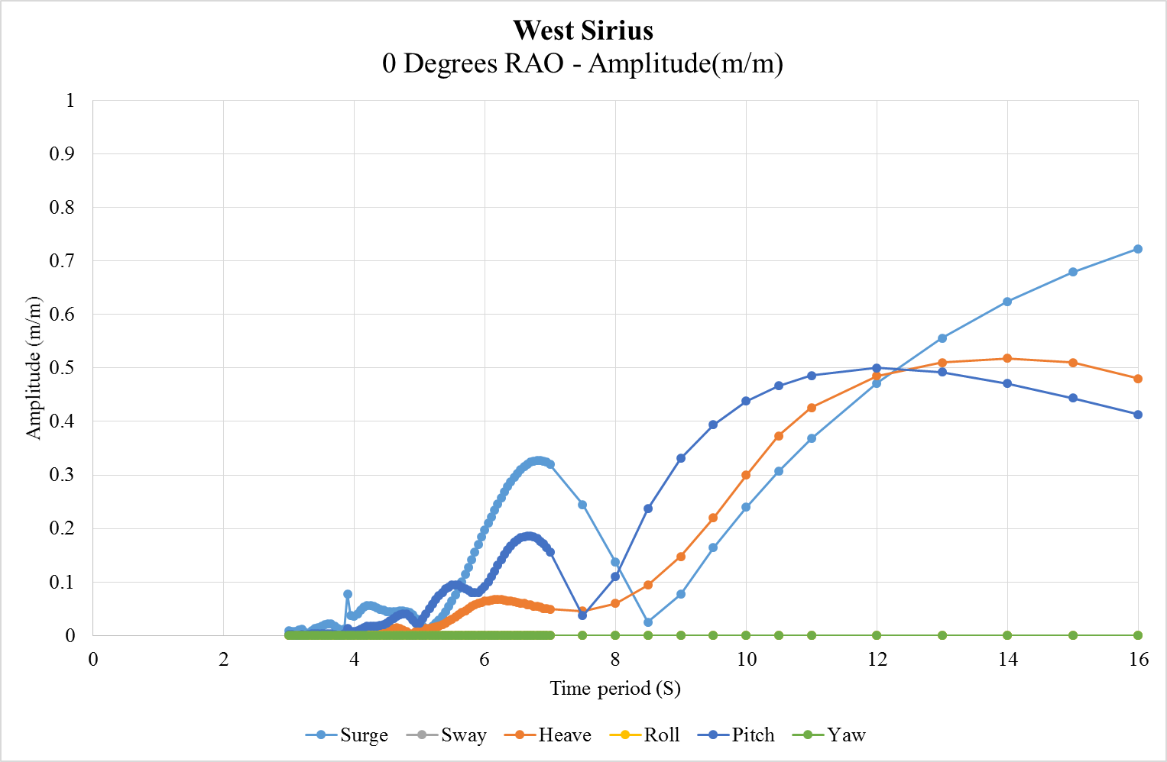

Figure 1 – 0 Degrees RAO’s Amplitude

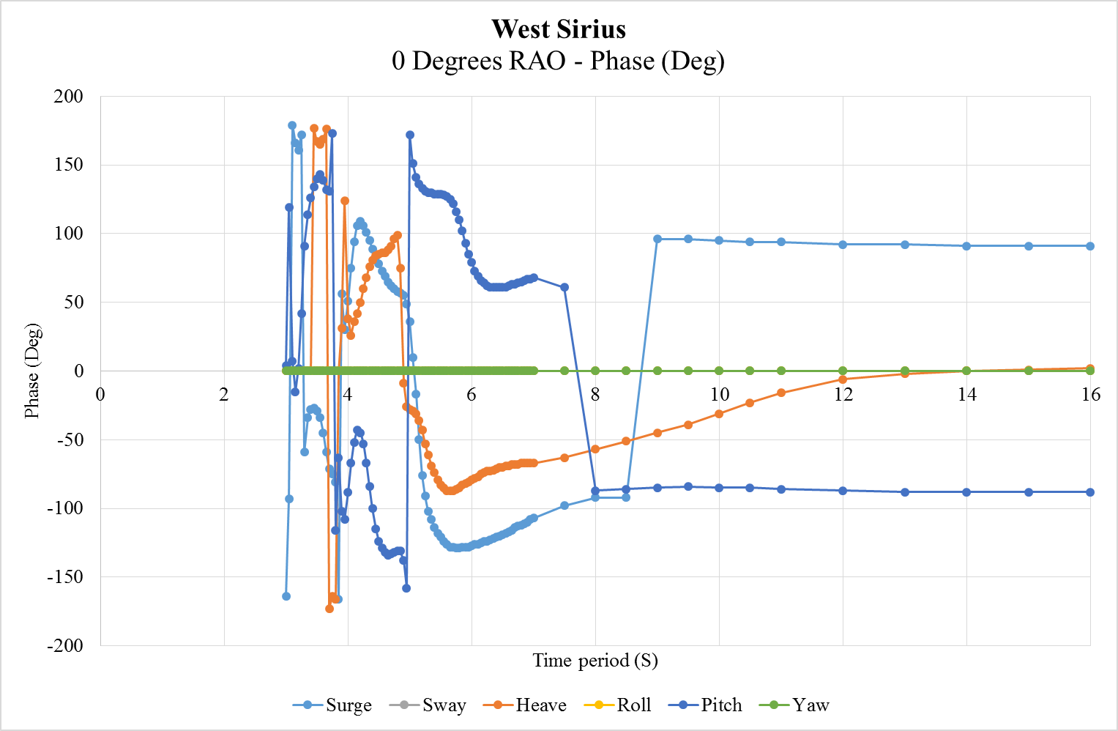

Figure 2 – 0 Degrees RAO’s Phase Angles

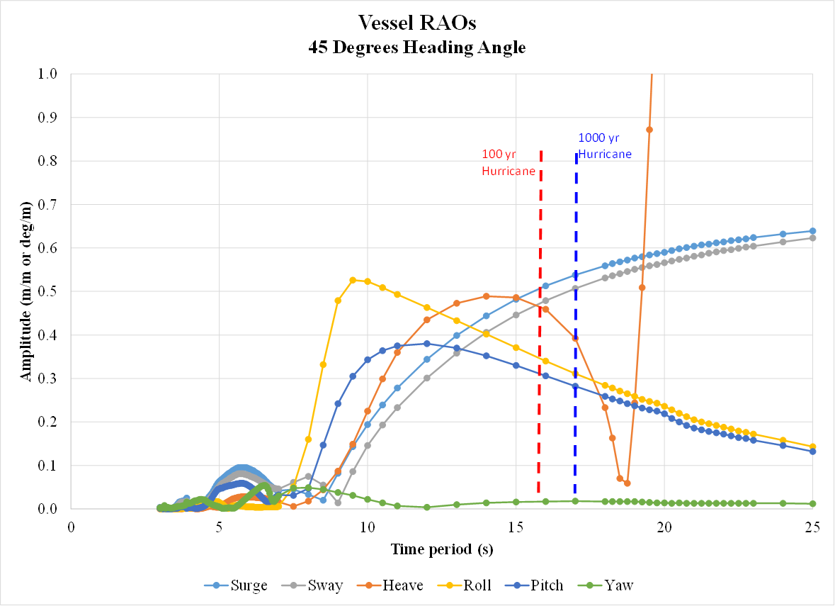

Figure 3 – 45 Degrees RAO’s Amplitude

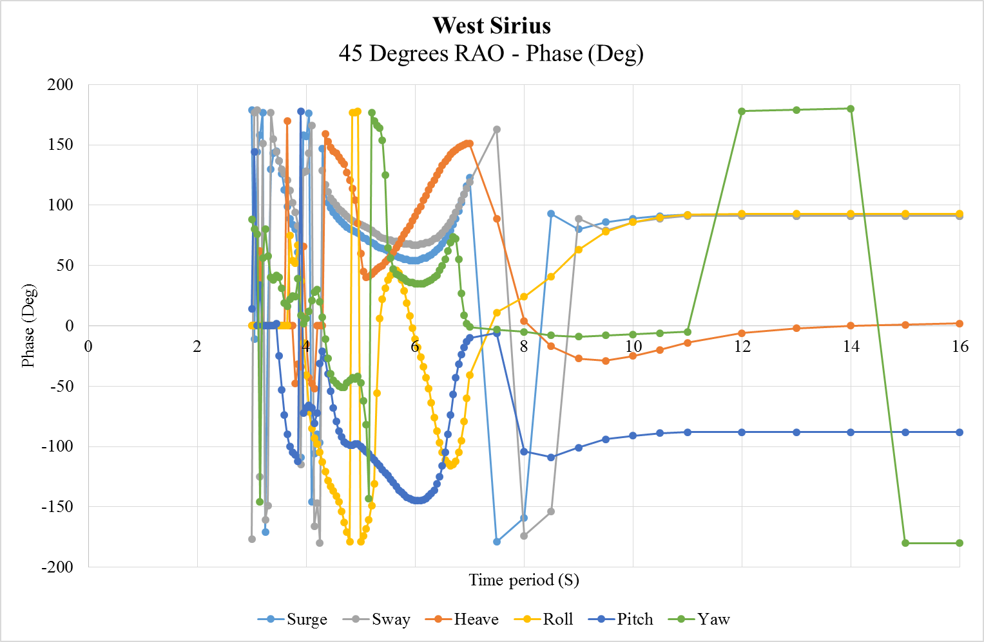

Figure 4 - 45 Degrees RAO’s Phase Angles

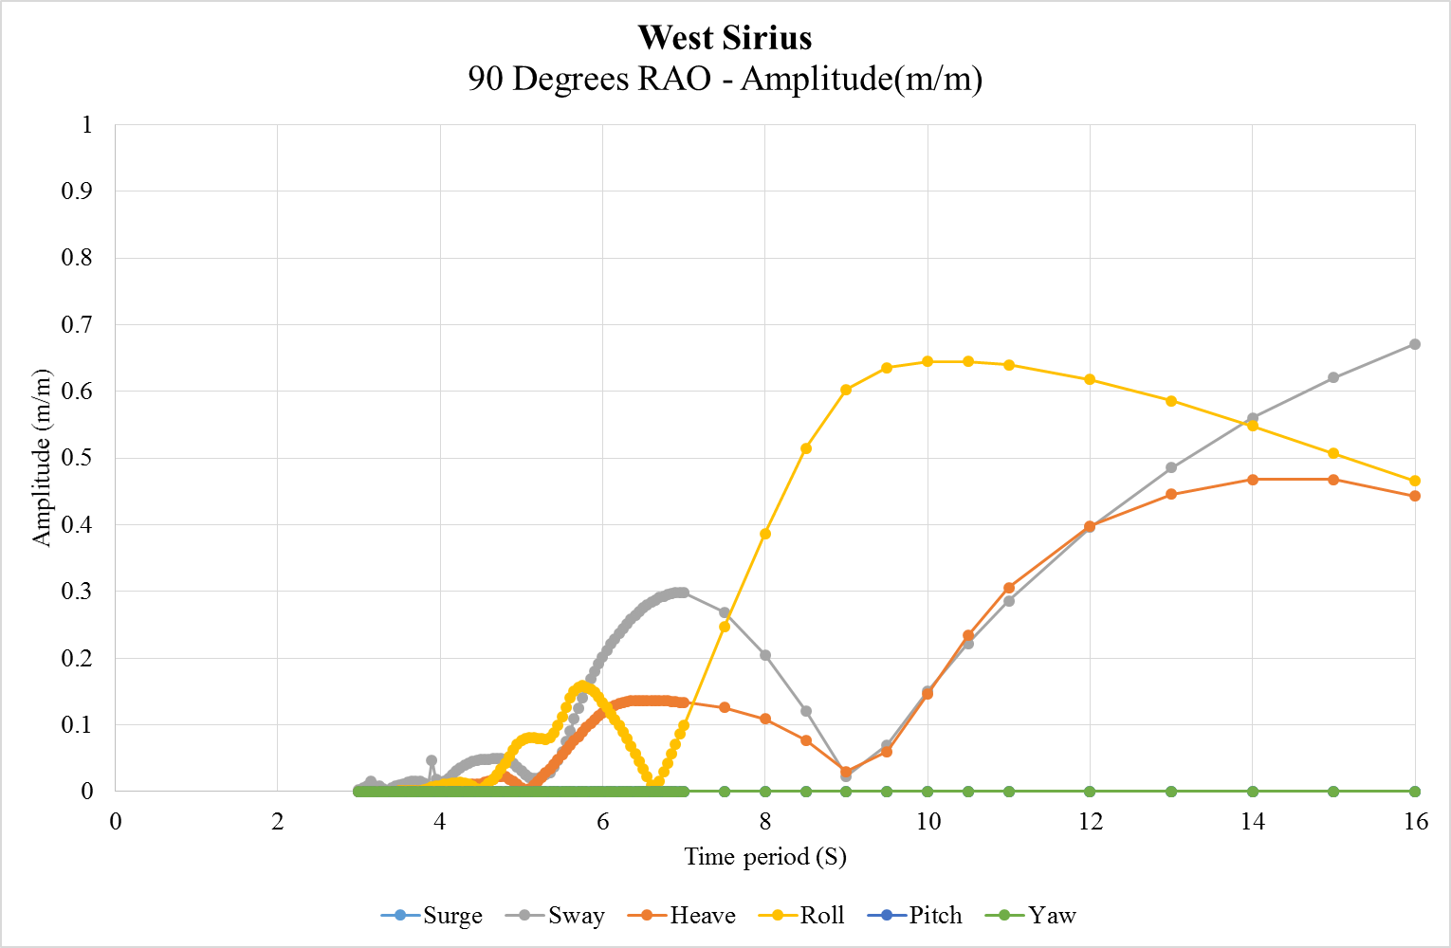

Figure 5 - 90 Degrees RAO’s Amplitude

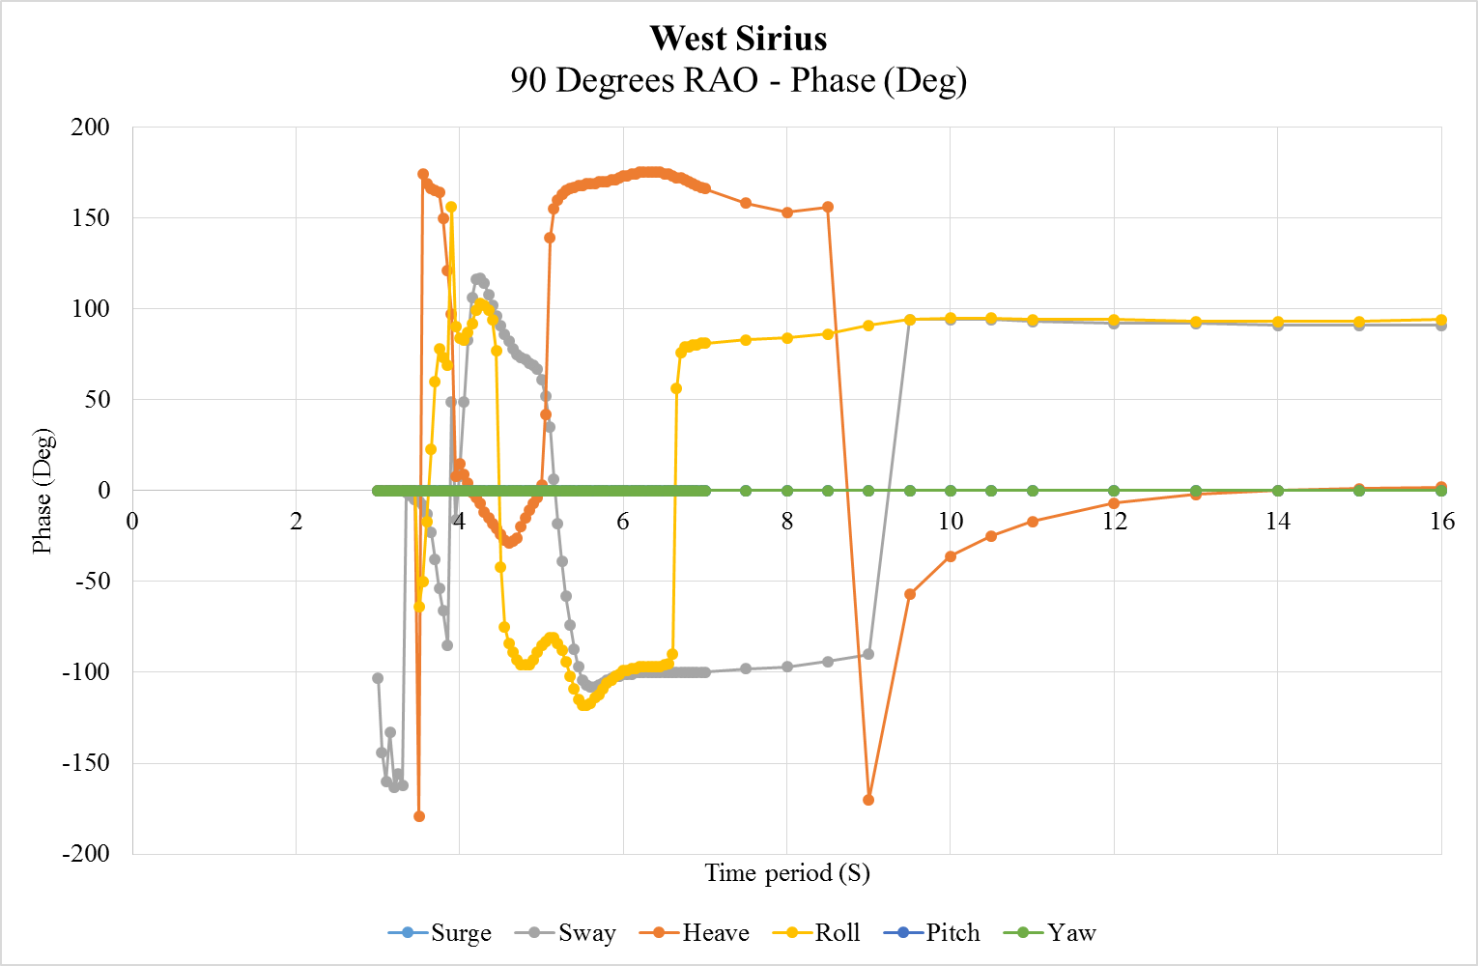

Figure 6 - 90 Degrees RAO’s Phase Angles

## Force coefficients

* Need to be defined so that the mooring forces can balance these forces

Force coefficients are available

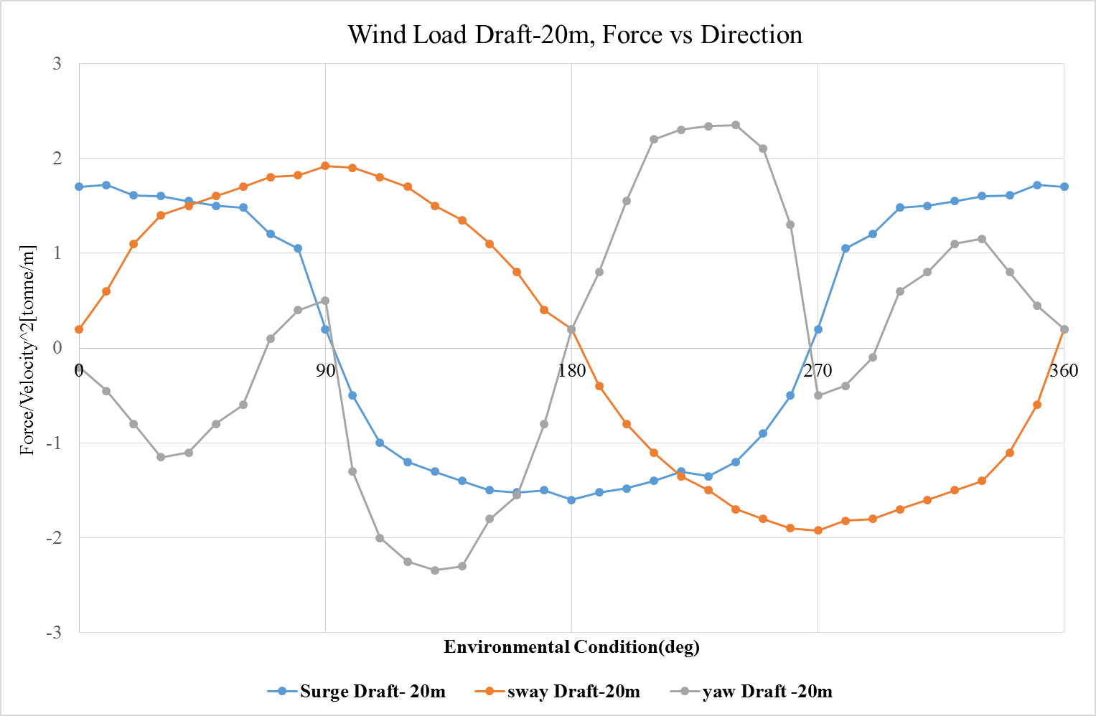

Figure 7 -Wind Load Draft-20 m, Force vs Direction

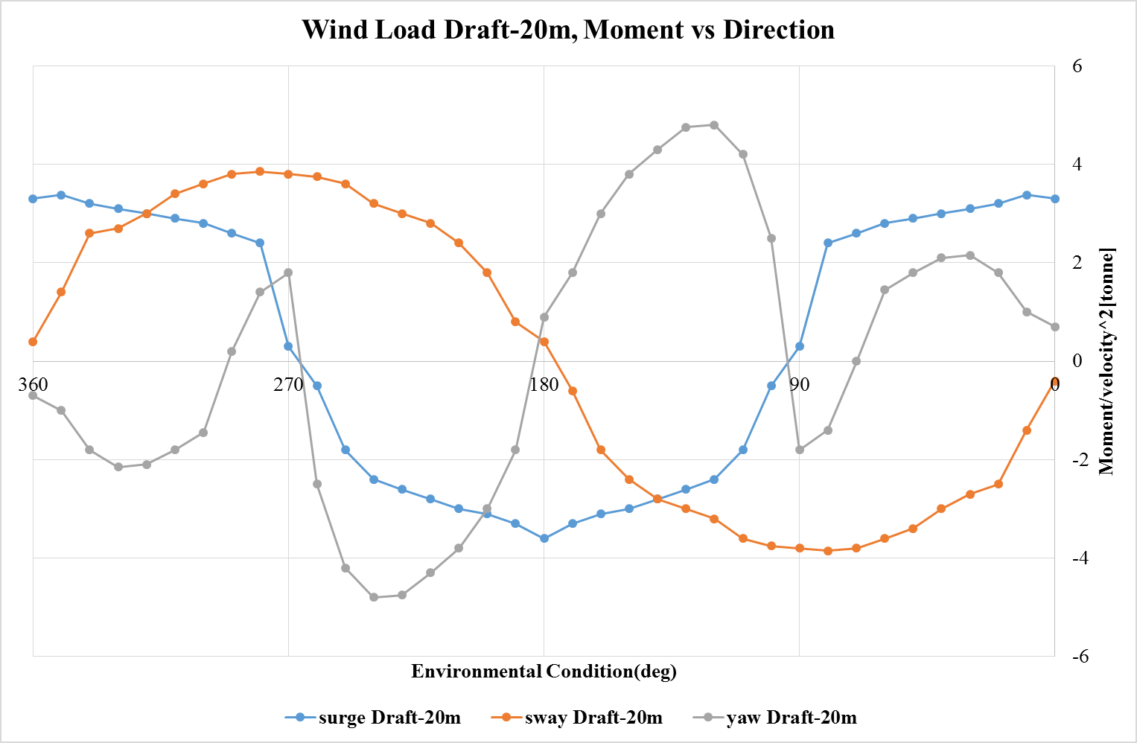

Figure 8- Wind Load Draft-20 m, Moment vs Direction

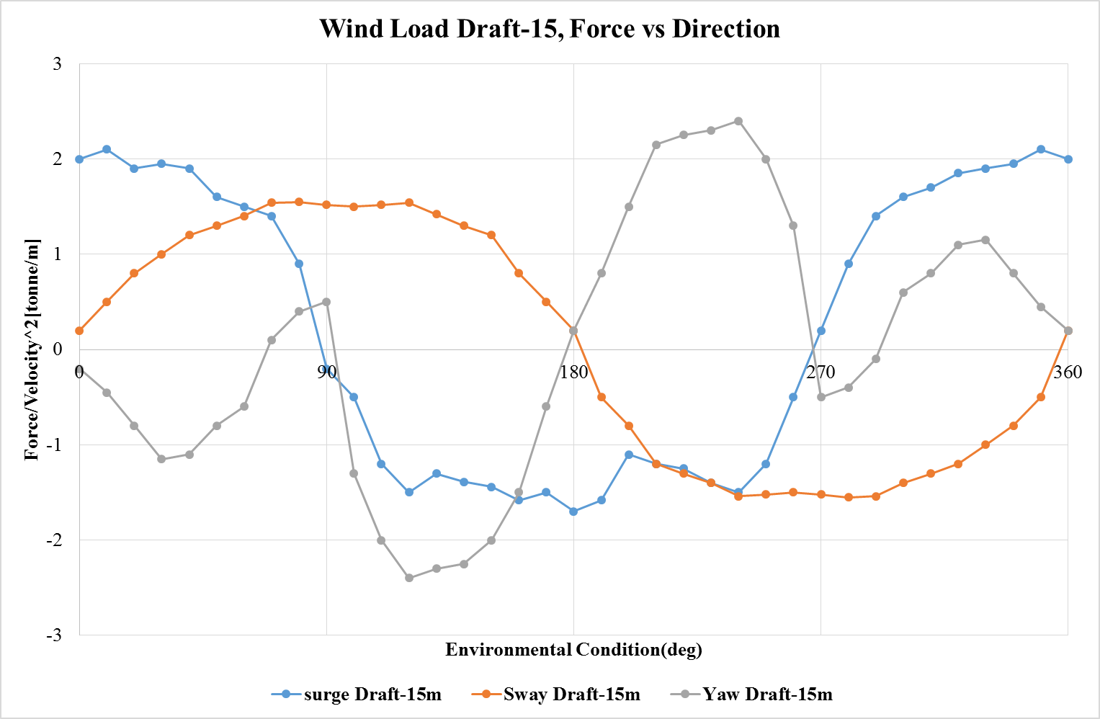

Figure 9- Wind Load Draft-15 m, Force vs Direction

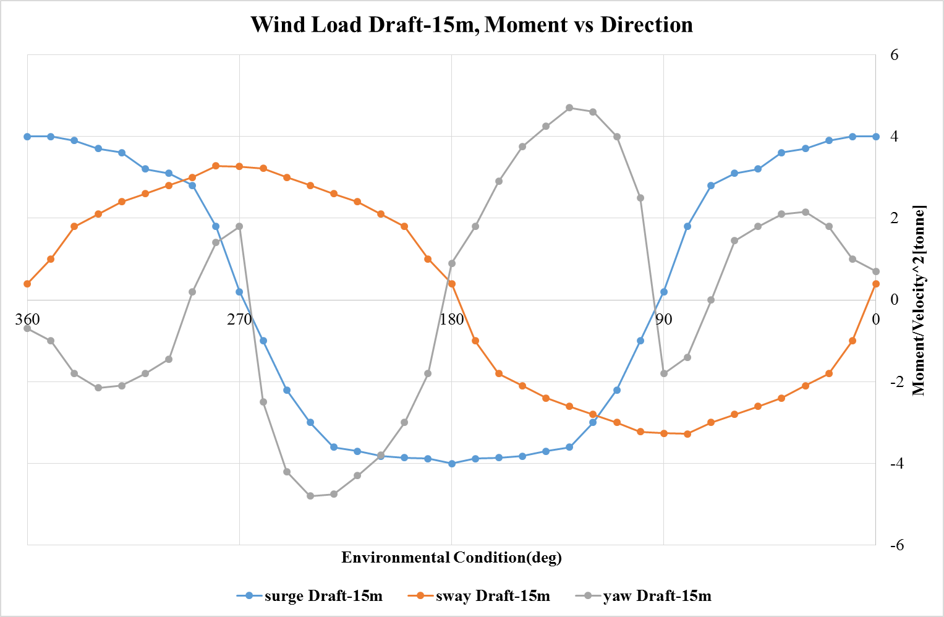

Figure 10- Wind Load Draft-15 m, Moment vs Direction

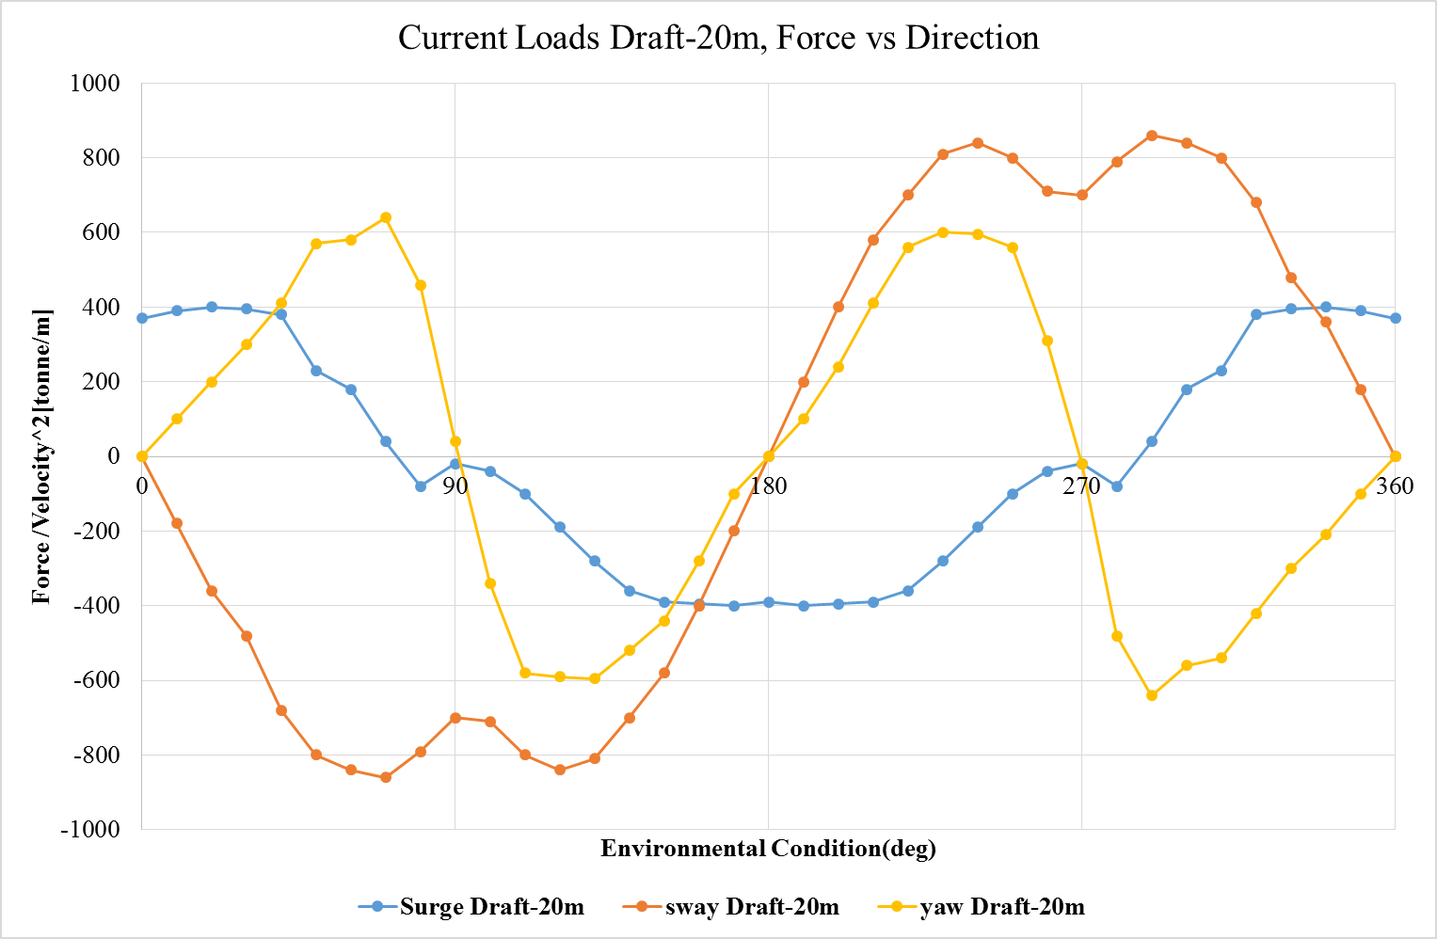

Figure 11- Current Load Draft-20 m, Force vs Direction

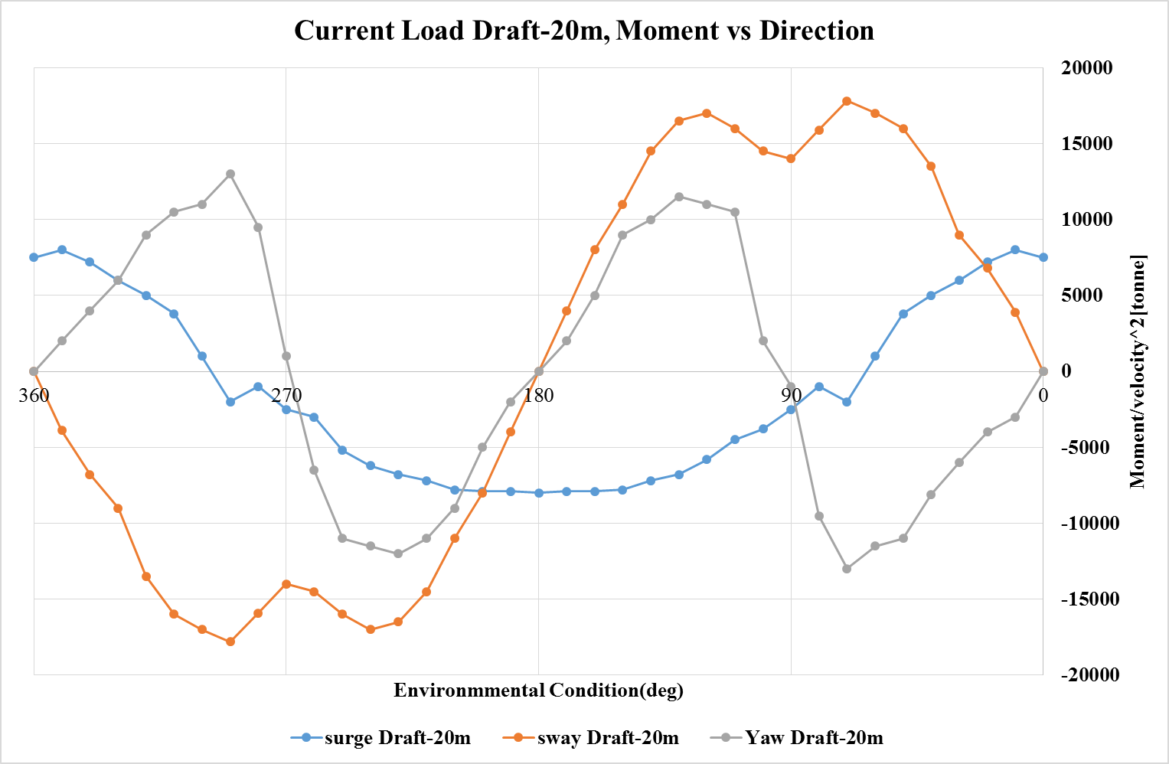

Figure 12-Current Load Draft -20 m, Moment vs Direction

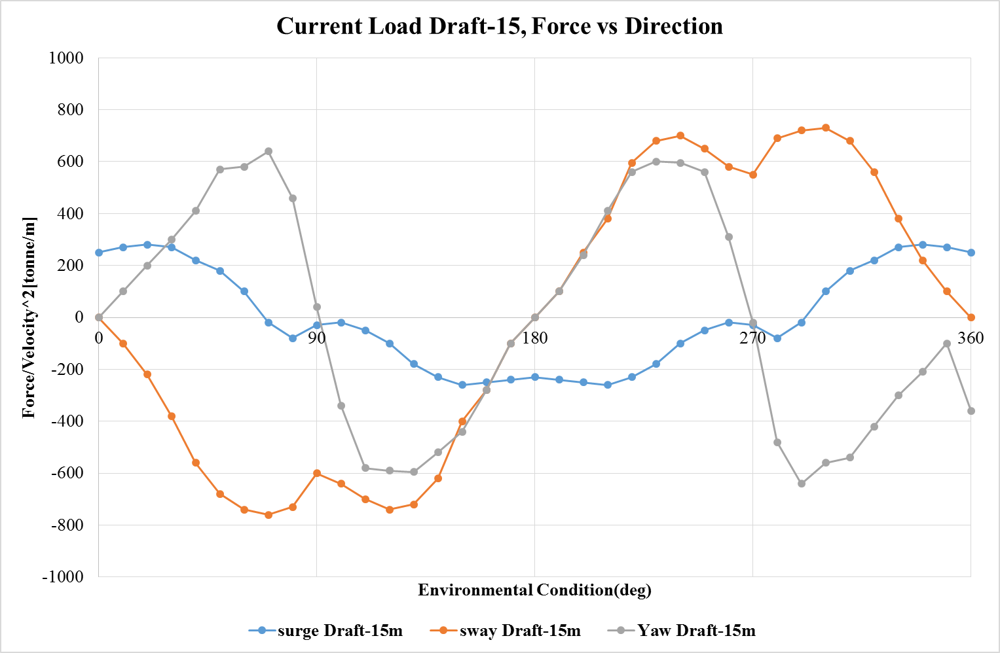

Figure 13-Current Load Draft-15 m, Force vs Direction

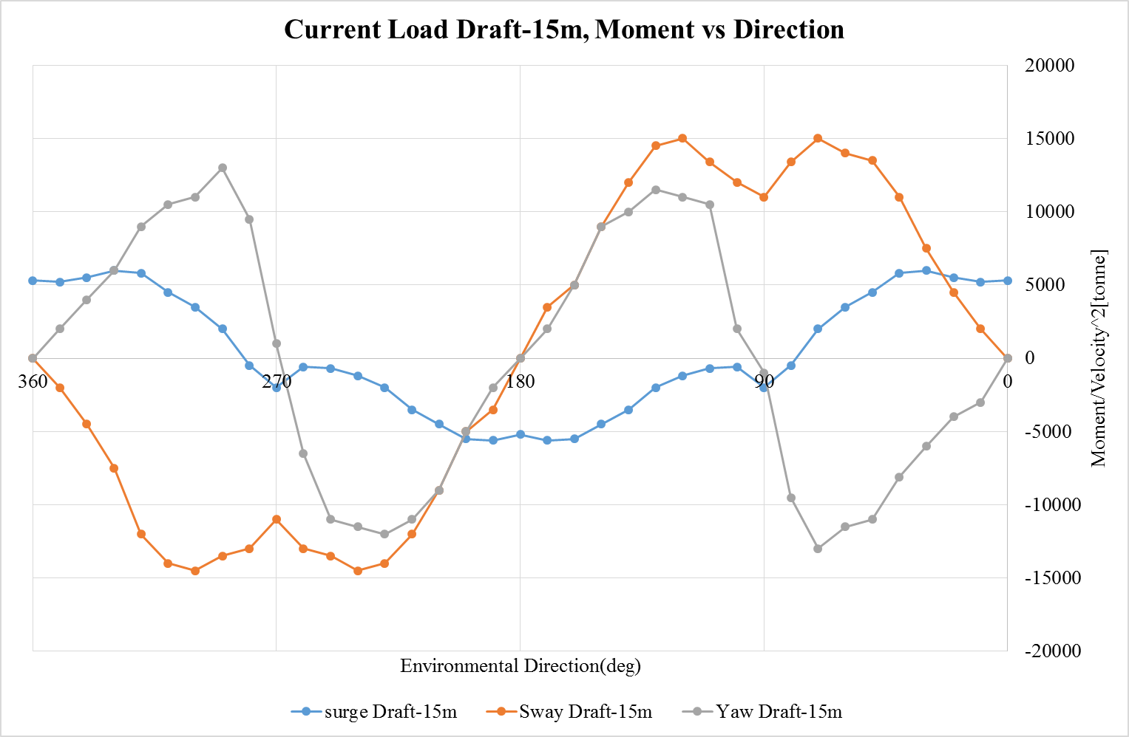

Figure 14- Current Load Draft-15 m, Moment vs Direction

# Water Depth

A water depth of 6000 ft. (1828 m) will be assumed for analysis.

# Mooring Configuration

* + The mooring system consists of four groups.
  + 80 deg, 100 deg, 80 deg, 100 deg used between groups to have similar response in both surge and sway directions for 45 deg environmental loading direction.
  + The mooring system is taut system.
  + Each mooring line consists of polyester rope with chain at the foundation pile and at the platform (chain-polyester-chain configuration).

8 and 12 point moorings considered

### Mooring system arrangement in particulates:

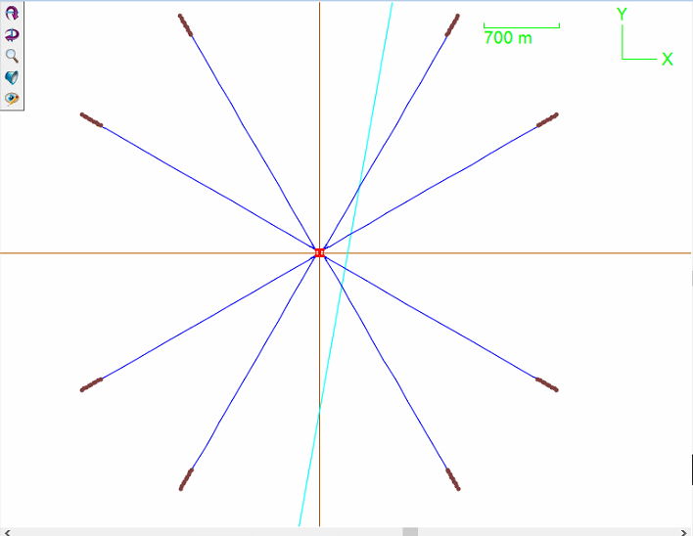 **Figure 15 – Top view of 8 point mooring arrangement**

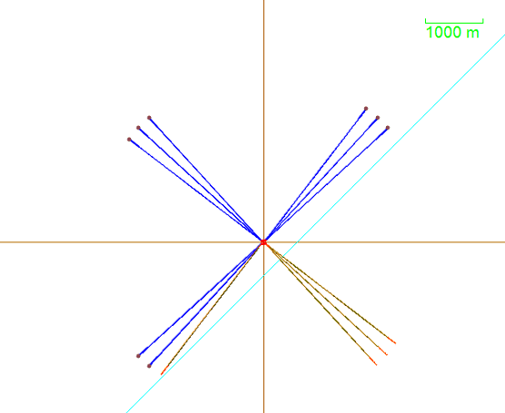

Figure 16- Top view of 12 point mooring arrangement

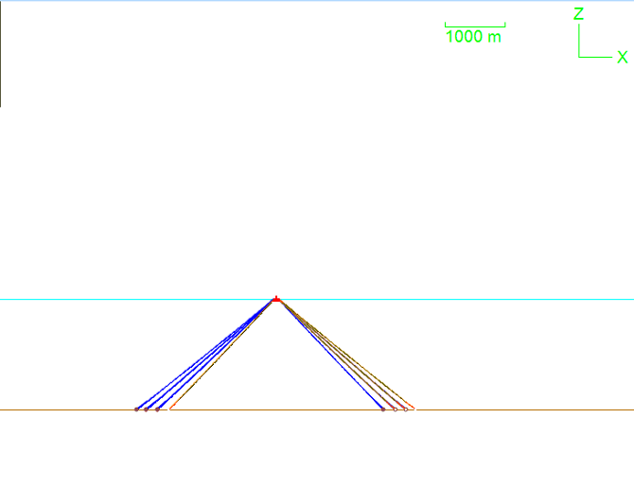 **Figure 17- Front View Arrangement**

14” Polyester rope with 2521m

10”chain with 250m length

10”chain with 100m length

### Vessel Position, 100 yr Hurricane Condition, 8 Point Intact Moorings, Configuration 4

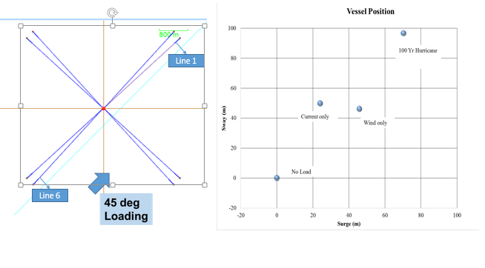

### Vessel Position, 100 yr Hurricane Condition, 12 Point Intact Moorings, Configuration 4

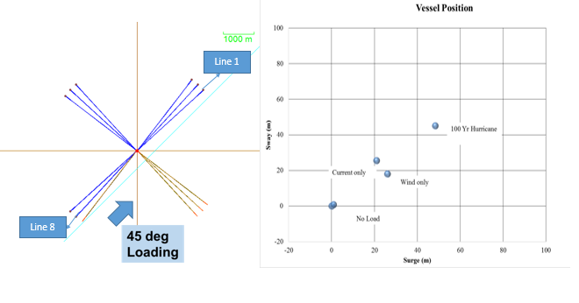

### 8 Point Mooring System, Effective Tension for Highest Tension Mooring Line-6, Configuration 4

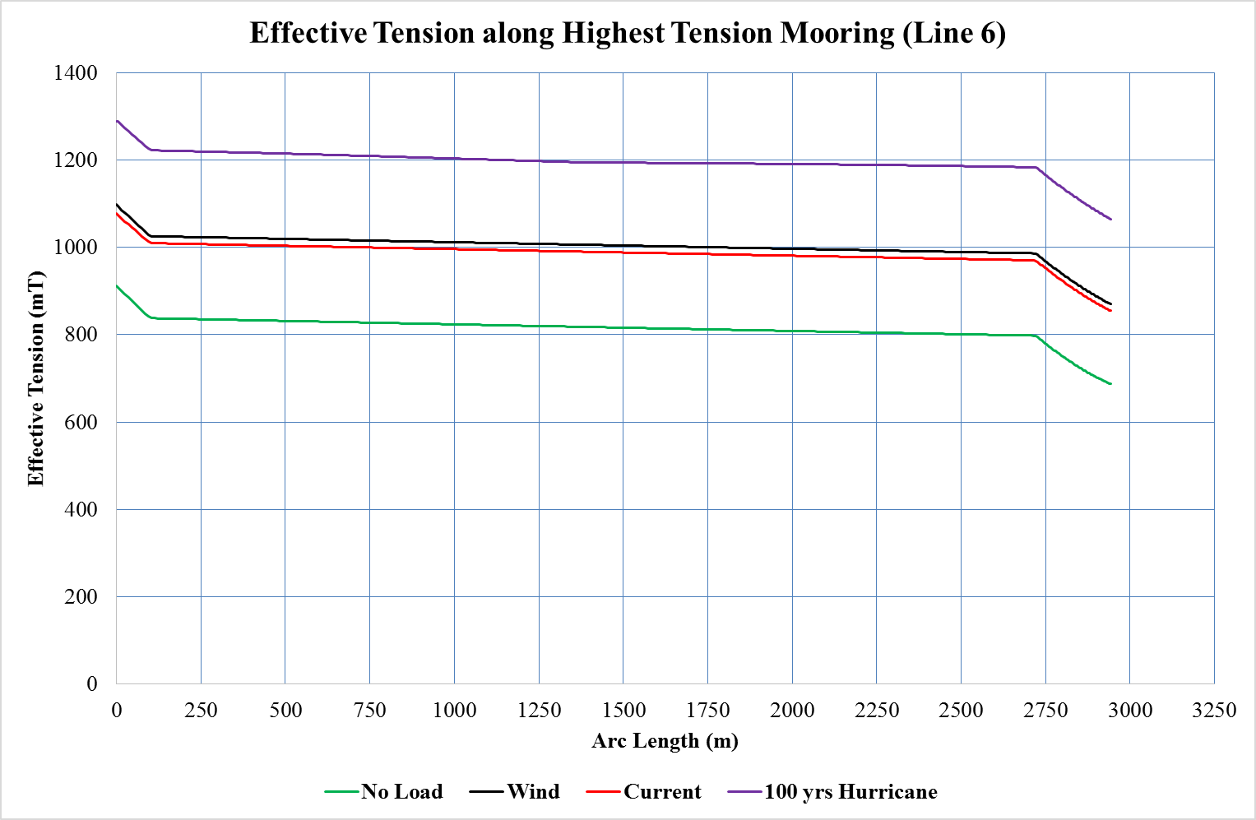

### 8 Point Mooring System, Effective Tension for Lowest Tension Mooring Line-1, Configuration

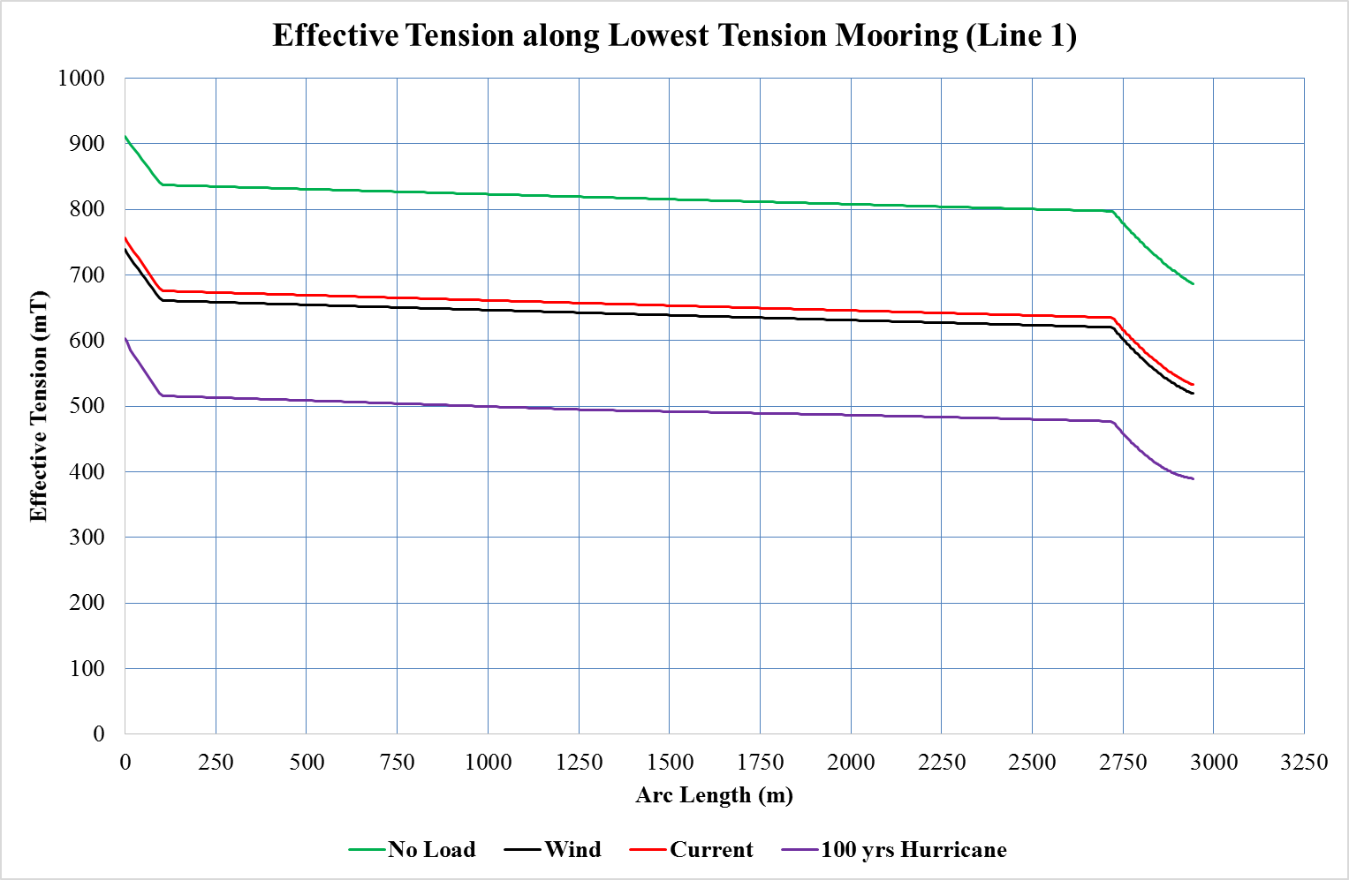

### 12 Point Mooring System Effective Tension for Highest Tension Mooring Line-8, Configuration 4

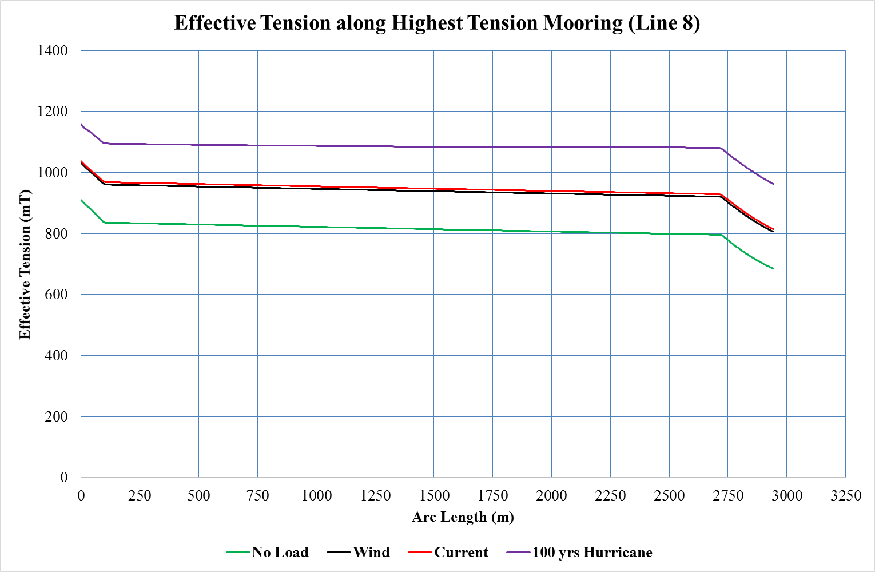

### 12 Point Mooring System, Effective Tension for Lowest Tension Mooring Line-1, Configuration 4

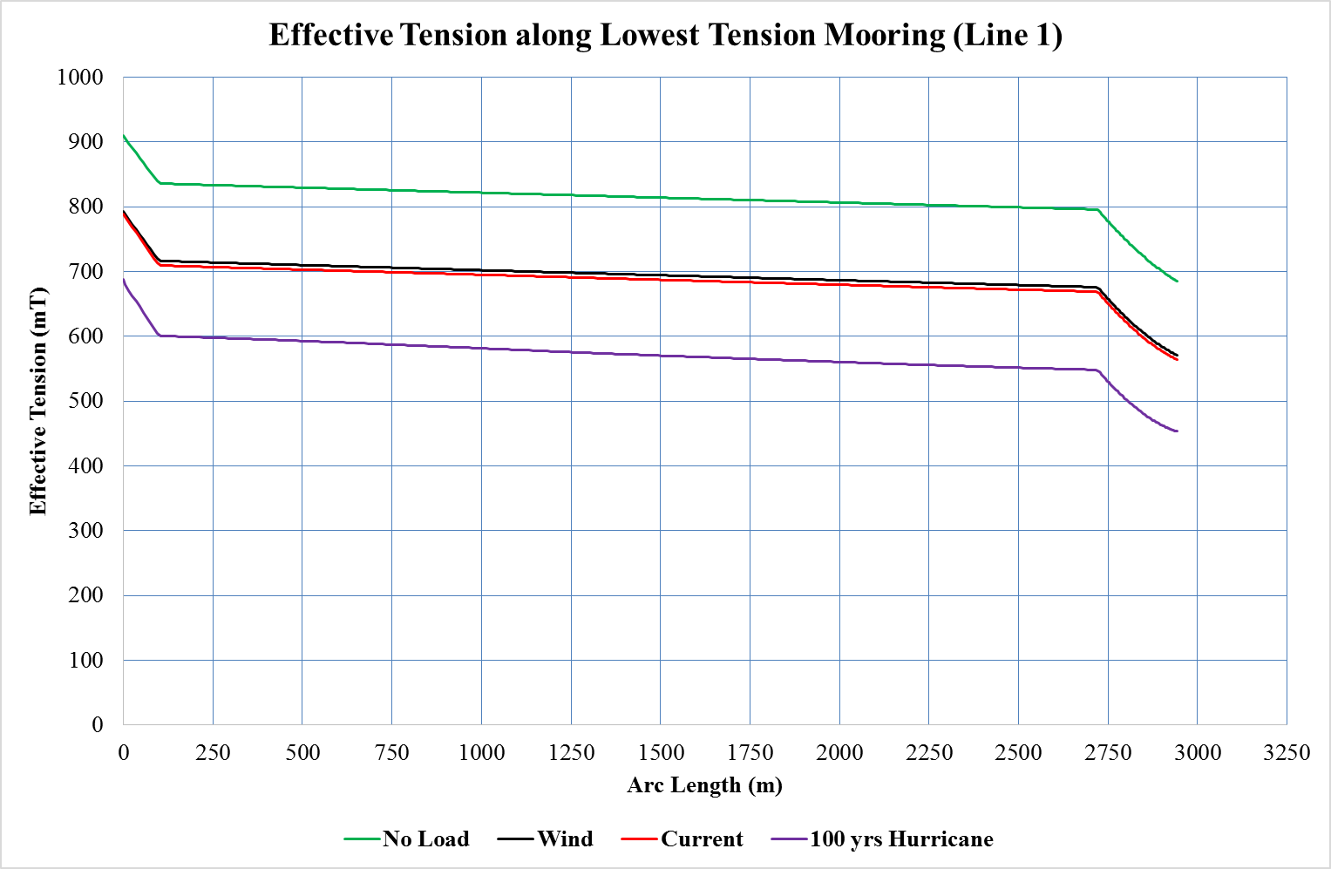

### Mooring System

Assumptions for report:

Passive mooring (No active winching). Active winching can improve offset response and thus reduce tensioner stroke requirements. However, active winching has its disadvantages

<http://www.offshore-mag.com/articles/print/volume-70/issue-1/engineering_-construction/alternative-synthetic.html>

The polyester mooring systems consisted of a suction pile anchor with a section of 3.5-in. (8.9-cm) insert wire, 6.3-in. (16-cm) polyester rope, an in-line submersible buoy, and 3.5-in. insert wire connecting into the MODU’s top component. For these systems there is no grounded length at survival tension.

The hybrid mooring systems consisted of a suction pile anchor with a section of 3.5-in. insert wire, 4.5-in. HMPE rope, 6.3-in. polyester rope, an in-line submersible buoy, and 3.5-in. insert wire connecting into the MODU’s top component. For these systems there once again is no grounded length at survival tension.

6,000-ft (1,828-m) water depth.

## Mooring Properties

By assuming the 8 point and 12point mooring model used for semi sub. These mooring consists of two types

* 14” Polyester rope
* 10”chain.

|  |  |  |  |
| --- | --- | --- | --- |
| **Properties** | **units** | **14”**  **Polyester Rope** | **10” Chain** |
| Nominal Diameter | m (ft) | 0.305 (1.00) | 0.254  (0.833) |
| Outer Diameter | m (ft) | 0.355  (1.164) | 0.457  (1.499) |
| Inner Diameter | m (ft) | 0 | 0 |
| Mass per unit length | Te/m | 0.101 | 1.284 |
| Type | - | Polyester (8- Multiplait) | studless |
| Weight in Air | Te/m | 0.101 | 1.284 |
| Weight in water | Te/m | 0.026 | 1.116 |
| Axial stiffness | KN | 1.4E5 | 5.5E6 |
| Minimum Breaking Load | Te | 2190 | 2134 |

Table 4- Mooring Properties

Note: By using orcaflex, taking above mooring properties like polyester rope and 10”chain, In this orcaflex model polyester rope length is 2580, Distance to anchor is 2421m and 6”chain length is 250m from seabed and 100m length from vessel.

# Riser data

Riser analysis is conducted with the following assumptions:

OD is 22” and thickness is 1.4”

No buoyancy is considered at top of region which can play critical role in down stroke when subjected to current loading

The riser is modeled as a single Casing pipe.

Tension factor of 1.4 with top tension of approximately 800 mT.

Tide, storm surge and vessel draft are assumed for the riser stroke analysis.

Riser stroke due to pressure and thermal expansion is assumed to be 1 m.

## Riser Configuration Summary

|  |  |  |  |  |
| --- | --- | --- | --- | --- |
| Riser Properties | Units |  | Units |  |
| OD | Inch | 22 | m | 0.5588 |
| WT | Inch | 1.4 | m | 0.03556 |
| ID | Inch | 19.2 | m | 0.48768 |
| Density |  |  | kg/m3 | 7850 |
|  |  |  |  |  |
| Steel Area |  |  | m^2 | 0.058454 |
| Steel Mass per Unit length |  |  | kg/m | 458.8621 |
|  |  |  |  |  |
| Internal Area |  |  | m^2 | 0.186793 |
| Internal Fluid |  |  | kg/m3 | 800 |
| Internal Fluid mass |  |  | kg/m | 149.4341 |
|  |  |  |  |  |
| External Area |  |  | m^2 | 0.245246 |
| External Fluid |  |  | kg/m3 | 1025 |
| External Fluid Buoyancy |  |  | kg/m | 251.3776 |
|  |  |  |  |  |
| Total Weight |  |  | kg/m | 356.9187 |
|  |  |  |  |  |
| Riser length |  |  | m | 1838 |
| Total weight of riser |  |  | kg | 656016.5 |
|  |  |  |  |  |
| Tension factor |  |  |  | 1.4 |
| Total Tension in Supporting Spring |  |  | N | 7722626 |
|  |  |  | kN | 7722.626 |
|  |  |  |  |  |
| **Tensioners** |  |  |  |  |
| No. of. Tensioners |  |  |  | 4 |
| Nominal Tension |  |  | KN | 1930.657 |
| Lower Limit (90% of Nominal) |  |  | KN | 1737.591 |
| Upper Limit (25% increase from Nominal) |  |  | KN | 2413.321 |

## Riser Stroke, 100 year Hurricane, Intact Mooring

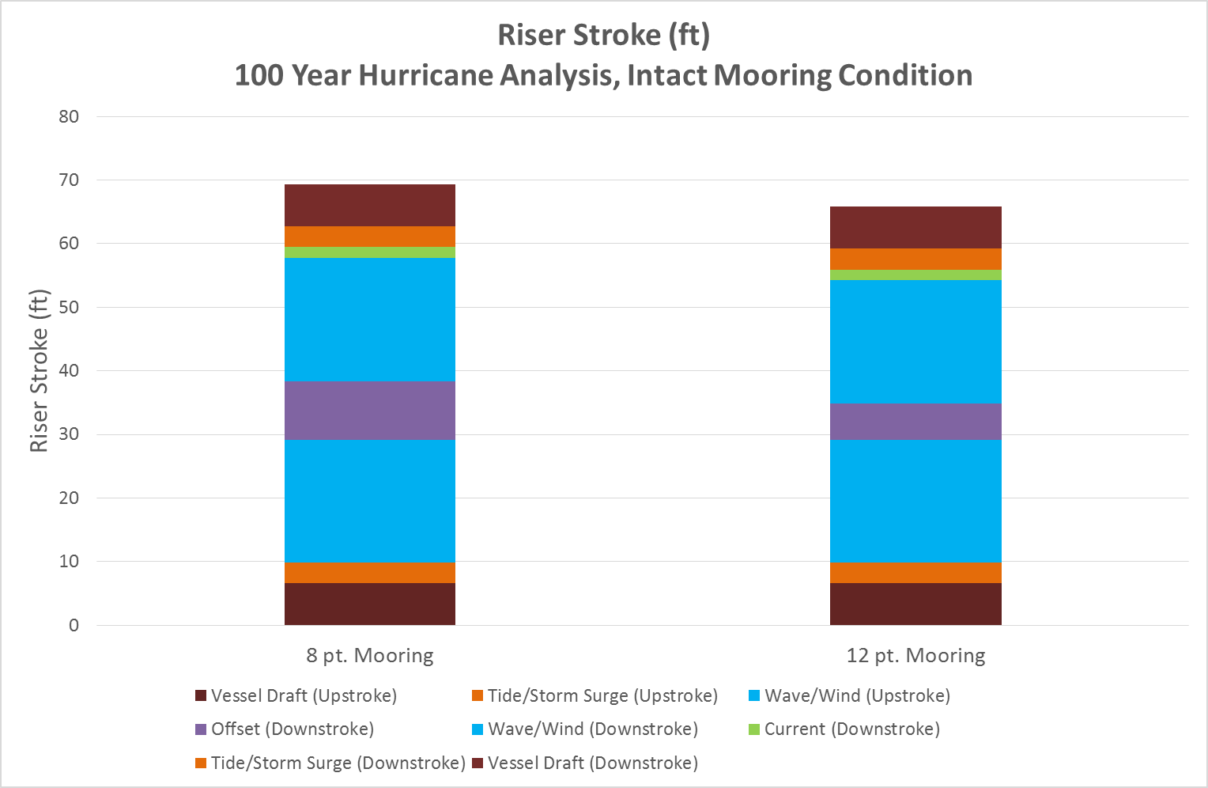

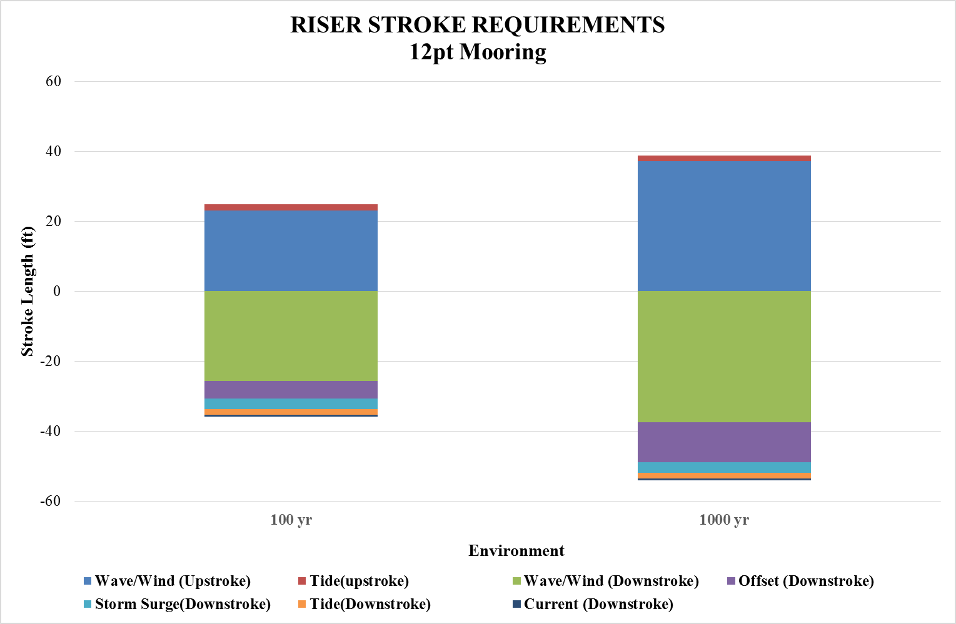

Figure 18- Riser Stroke Requirements for 12pt Mooring

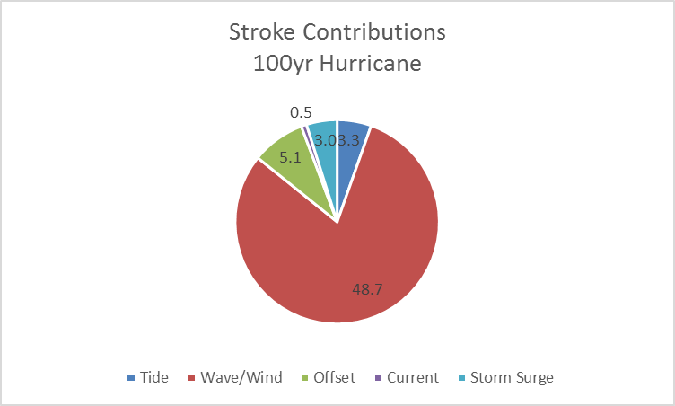

Figure 19- 100 yr. Stroke Contributions in Graphical Form

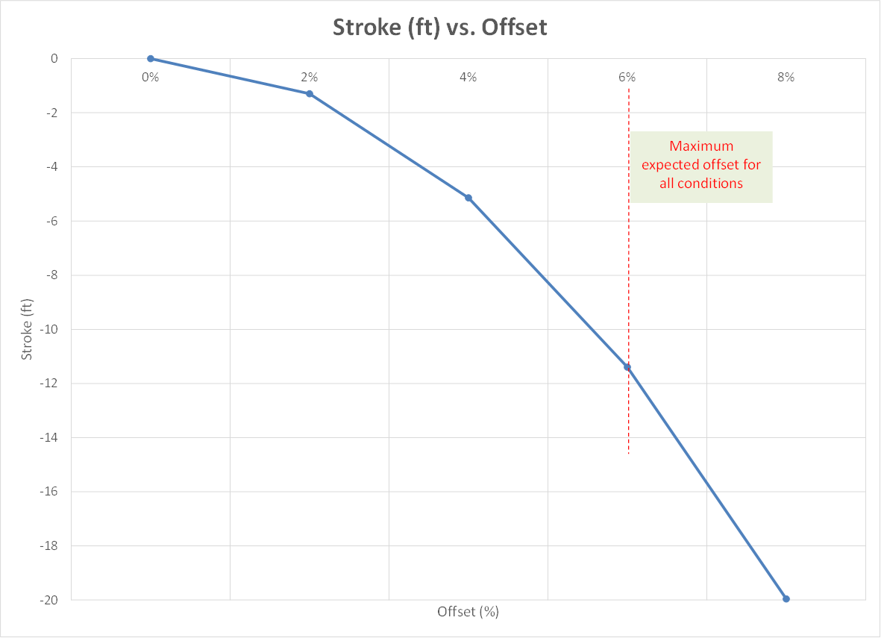

Figure 20- Stroke vs Offset

|  |  |  |
| --- | --- | --- |
| **Riser Stroke(ft.)** | | |
| **Description** | **100yr** | **1000yr** |
| Tide(upstroke) | 1.6 | *1.6* |
| Wave/Wind(upstroke) | 23.2 | 37.2 |
| Offset(Down Stroke) | 5.1 | 11.4 |
| Wave/Wind(Down Stroke) | 25.5 | 37.4 |
| Current(Down Stroke) | 0.5 | 0.5 |
| Storm Surge(Down Stroke) | 3.0 | 3.0 |
| Tide(Down Stroke) | 1.6 | 1.6 |
| Total | 61 | 93 |
|  |  |  |

Table 5- Riser Stroke analysis

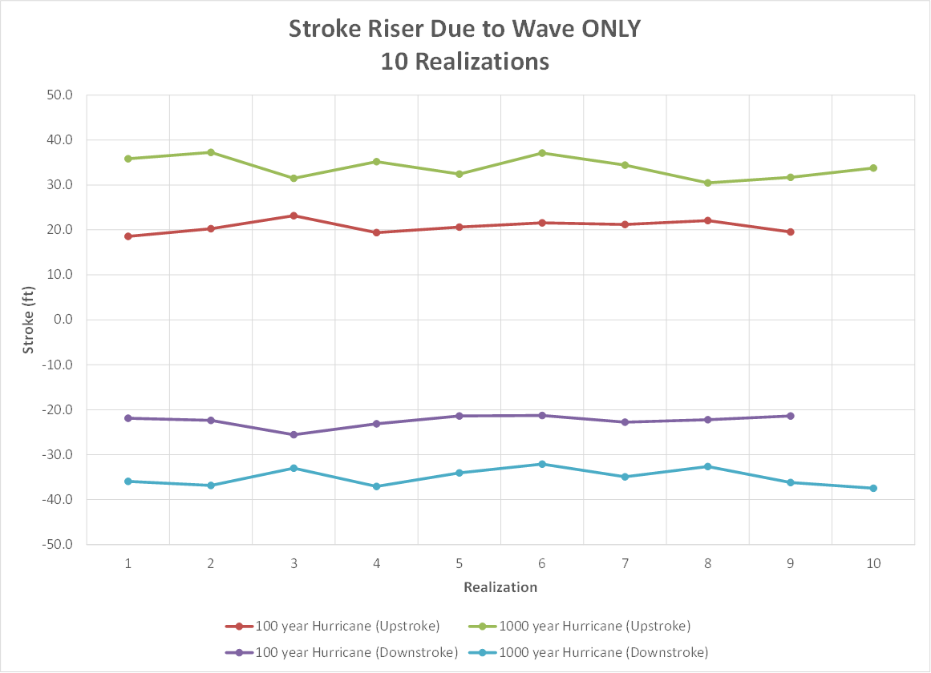

Figure 21- Stroke vs Realizations



# Analysis Methodology

The analysis methodology used for the mooring analysis is given in this section.

The high level general analysis data considered for the analysis is given in this section. This is considered acceptable to determine the vessel offsets and heave motions.

To account for 2nd order dynamic motions, a dynamic factor of 1.2 will be used for the vessel offset (and subsequent stroke contribution).

|  |  |  |
| --- | --- | --- |
| **Phenomenon** | **Limitation** | **Analysis Consideration** |
| Wind and Current forces | Force coefficients | Yes |
| 2nd order dynamic motions | Load RAOs & added mass/stiffness coefficients not available | No |
| 1st order motions | Motion RAOs available | Yes |

Table 6 – High Level Analysis Methodology

## Design Criteria

### Tension Safety Factors

Mooring pretension: 30% of breaking load to avoid wearing of the mooring wire rope

??? 1 : 2 for the MBL?(should be confirmed)

### Anchor Uplift Angles

Tension safety factors

Anchor uplift angles

L:\O&G\By Topic\Mooring\STA MRE Research\Codes\API RP 2SK 3rd Ed (2005) Stationkeeping.pdf

Polyester /Synthetic ropes:

L:\O&G\By Topic\Mooring\STA MRE Research\Codes\API RP 2SM 1st Ed & Addendum (2001 & 2007) Synthetic Fibre Ropes for Mooring.pdf

### Configuration Criteria

**Mooring system configuration**

* + The mooring system consists of four groups.
  + 80 deg, 100 deg, 80 deg, 100 deg used between groups to have similar response in both surge and sway directions for 45 deg environmental loading direction.
  + The mooring system is taut system.
  + Each mooring line consists of polyester rope with chain at the foundation pile and at the platform (chain-polyester-chain configuration).
  + 8 and 12 point moorings considered.

**Polyester Rope distance from Seabed**

Polyester rope is known to have detrimental effects on the polyester mooring when in touch with seabed. The sand particles typically erode away the intertwined layers. Therefore, analysis should be performed to have sufficient distance above seabed.

**Mooring on ground**

The amount of mooring on ground during extreme and survival events is important to help understand the impact.

Offsets allowed:

Restrict to 4%.

# Riser stretch analysis

## Design Criteria

14.75" X 11.75" Equivalent Riser. Riser is built up with LMRP, BOP, buoyancy joint and slick joint. The total length of riser is 6049.2 ft.Top tension of 800 kips. A group of 4 top tension production risers to be modelled for 6000 ft water depth. A 6thGen semi-submersible is considered for analysis.

## Analysis Methodology

Analysis is used in two methods, these are Elastic and Elastic-Plastic Materials (Ramberg-Osgood relationship) methods.

* The stretch analysis for stretch analysis, vessel upwards (or heave up) by ~60 ft.
* For slack analysis, vessel moves (or heave up) by ~60 ft

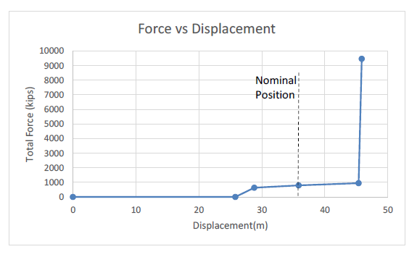

Figure 22- Non-linear force-displacement Tensioner curve

* Upwards heave of up to 20 ft(in excess of tensioner stroke) can be accommodated by the riser stretch
* An additional force of ~7000 kips per riser is observed on the riser cart
* Strain limitations and implications are to be understood for 125 ksi riser material
* Riser design is feasibility for an unmodified SEMI heave RAO. Riser design for a modified SEMI for lower heave RAO will help improve the feasibility
* Downwards heave of up to 20 ft(after tensioner slacks) can be accommodated by the riser slack
* Therefore, excess heave can be comfortably accommodated by riser design without gross failure.
* Therefore, excess heave can be comfortably accommodated by riser design without gross failure.
* Plastic deformation of cart/riser may need to be inspected prior to resuming operations post 100 year or higher return period hurricanes.

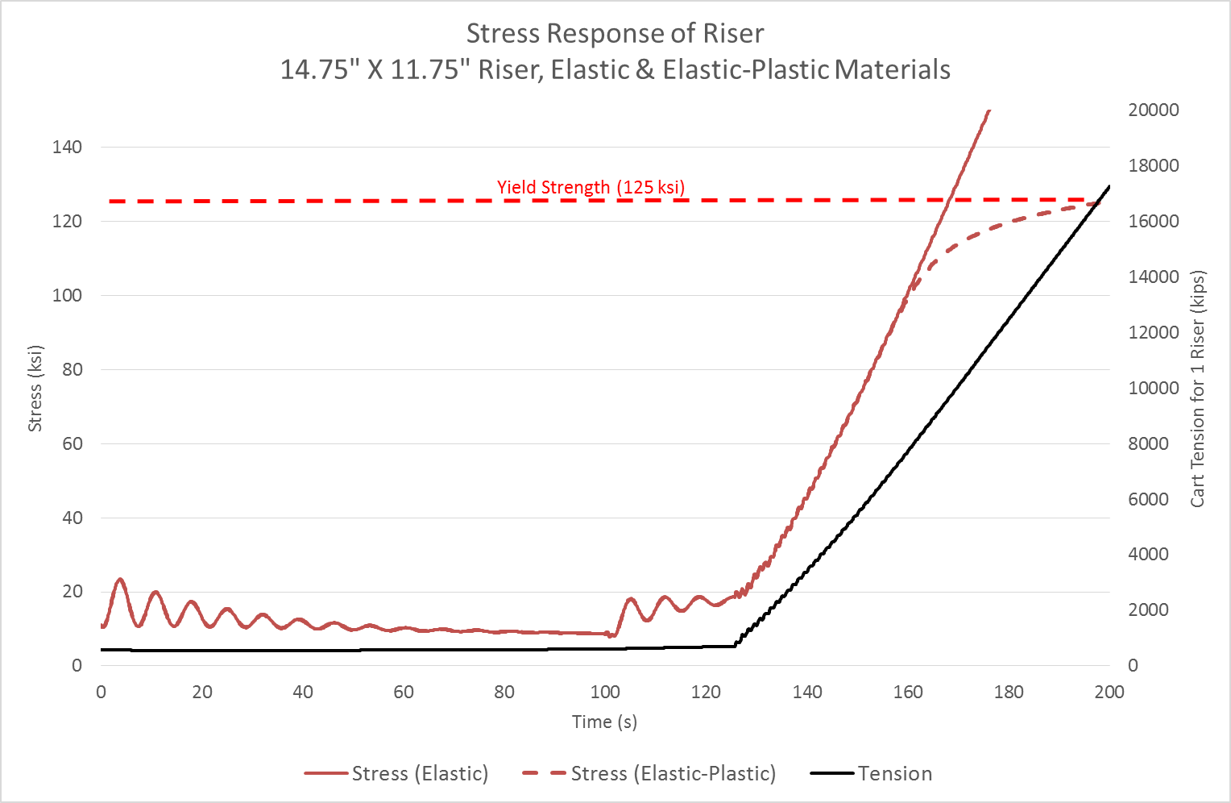

Figure 23- Riser Stress Response -Riser Stretch

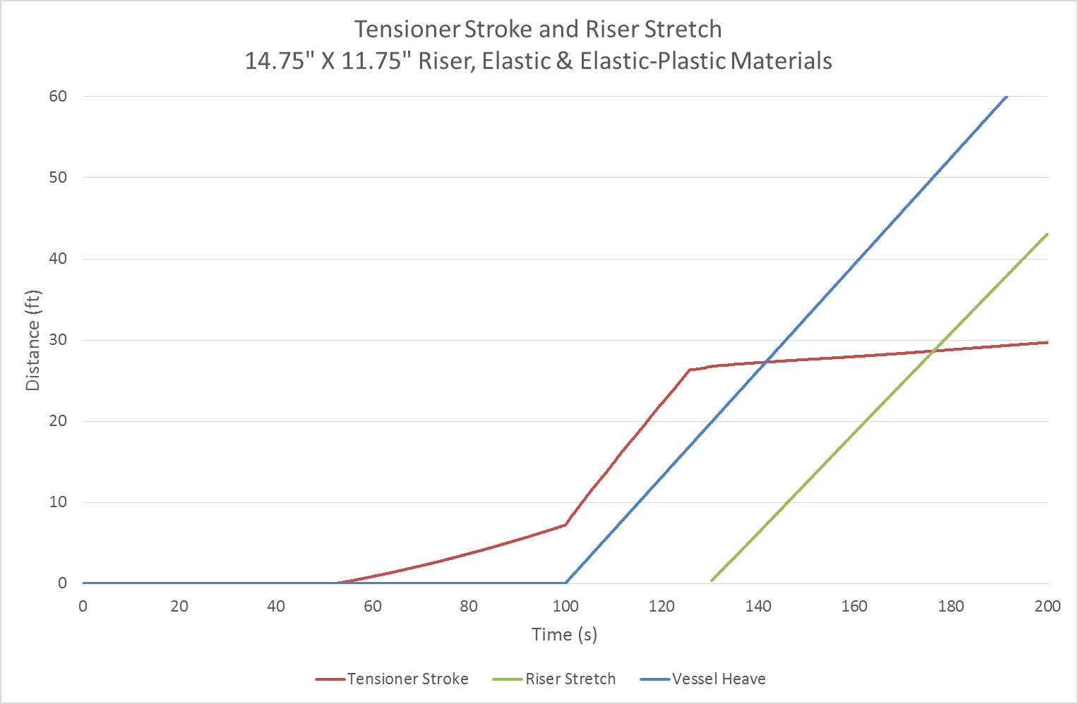

Figure 24- Tensioner Stroke -Riser Stretch

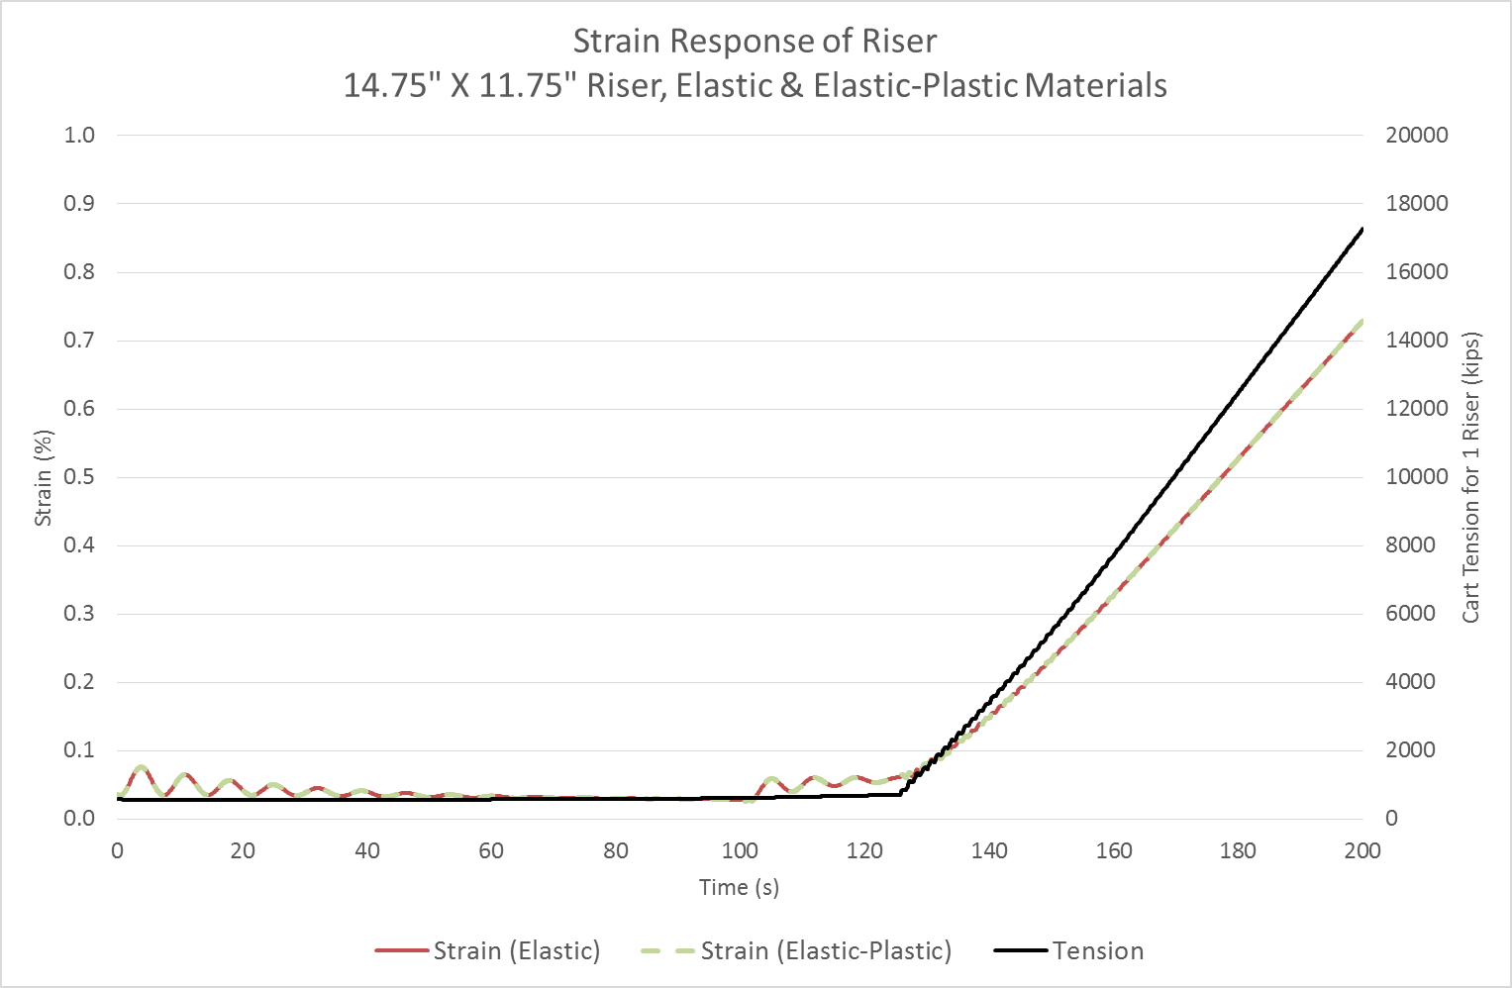

Figure 25- Riser Stress Response -Riser Stretch

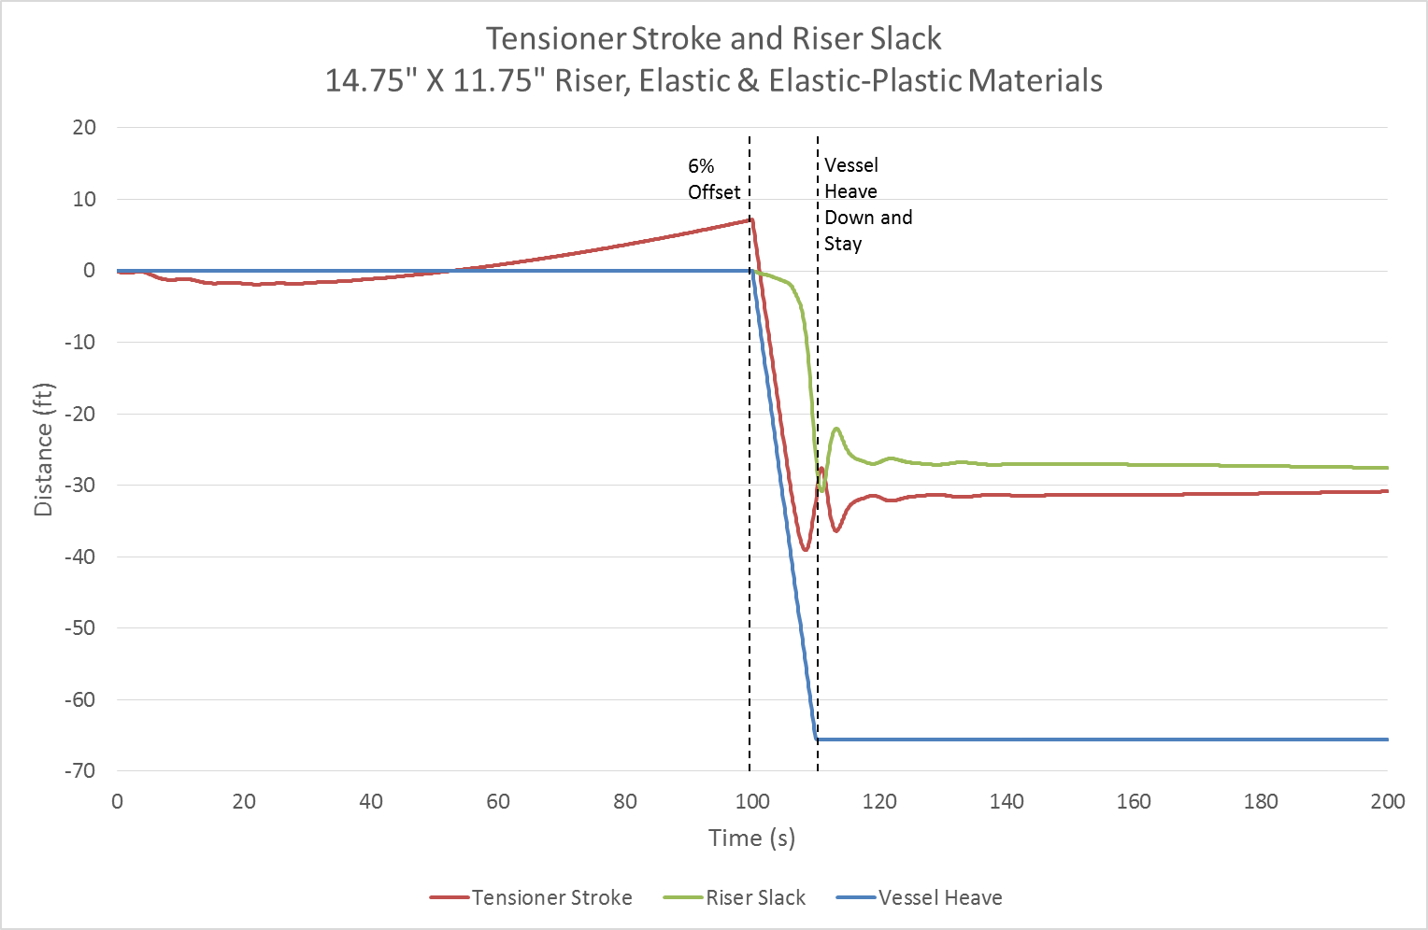

Figure 26- Tensioner Stroke -Riser Slack

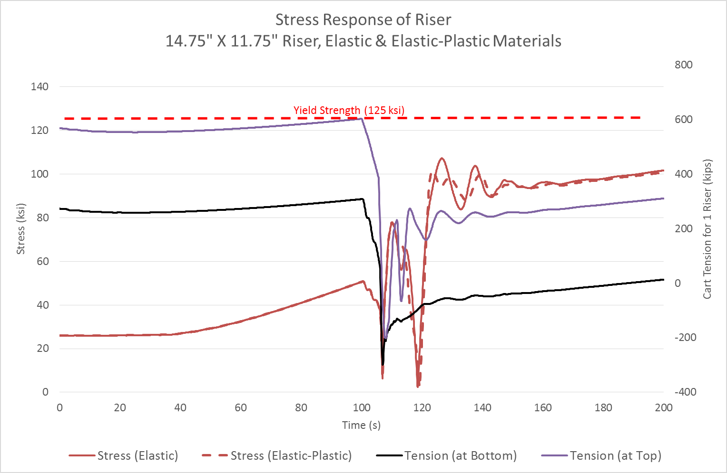

Figure 27- Riser Stress Response - Riser Slack

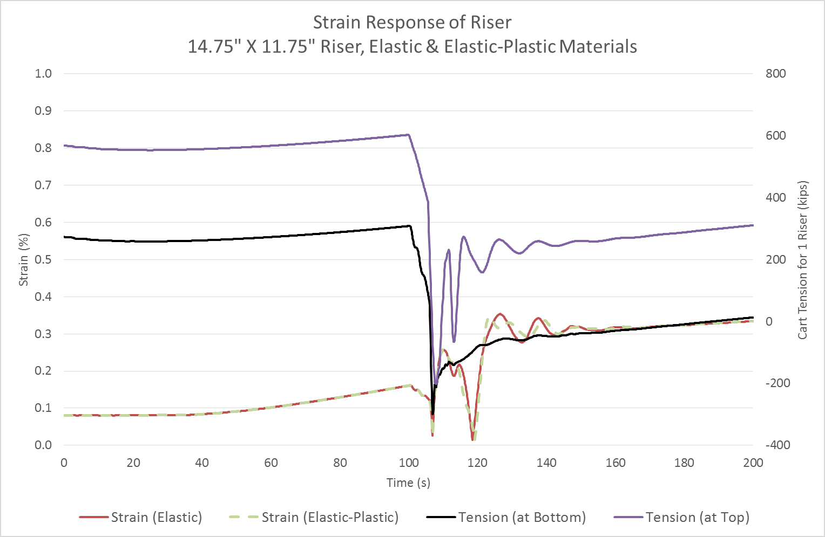

Figure 28- Riser Tensile Strain Response -Riser Slack

# References

1. API, " Design and Analysis of Stationkeeping Systems for Floating Structures ", API RP 2SK, 2005
2. API, "Synthetic or fiber rope??", API 2I, September, 1995
3. API, "Metocean", API-RP-2MET, 2014.
4. API, "Recommended Practice for Completion/Workover Risers", API-RP-17G, 2006.

- Vessel Data Dimensions

A 6th generation semi-submersible is considered for the analysis. The key vessel dimensions of the vessel are listed in Table 1.

|  |  |  |
| --- | --- | --- |
| **Main Particulars** | | |
| Overall length | | 380.51 ft (115.98 m) |
| Beam | | 304.56 ft (92.83 m) |
| **Upper Hull** | | |
| Length | | 244.2 ft (74.42 m) |
| Breadth | | 244.2 ft (74.42 m) |
| Depth | | 28.2 ft (8.6 m) |
| **Lower Hulls** | | |
| Length Overall | | 324.2 ft (98.82 m) |
| Breadth (Amidships) | | 66 ft (20.12 m) |
| Depth | | 28 ft (8.54 m) |
| Corner Radius | | 7 ft (2.13 m) |
| Transverse Distance (CL to CL) | | 192.1 (58.56 m) |
| **Columns** | | |
| Number of Columns on each Pontoon | | 4 |
| Horizontal Section (L x B) – Column Top | | 52.0 ft x 52.0 ft (15.86 m x 15.86 m) |
| Horizontal Section (L x B) – (14.0 m above B.L.) | | 52.0 ft x 58.9 ft (15.86 m x 17.95 m) |
| Horizontal Section (L x B) – (22.0 m above B.L.) | | 52.0 ft x 58.9 ft (15.86 m x 17.95 m) |
| Horizontal Section (L x B) – (Column Bottom) | | 52.0 ft x 52.0 ft (15.86 m x 15.86 m) |
| **Moon pool** | | |
| Length (Transverse) | 140 ft (42.7) | |
| Width (Longitudinal) | 28 ft (8.5) | |

Table 7 – Key Vessel Dimensions



- Vessel Hull Dimensions

|  |  |  |
| --- | --- | --- |
| **Main Particulars** | | |
| Overall length | | 380.51 ft (115.98 m) |
| Beam | | 304.56 ft (92.83 m) |
| **Upper Hull** | | |
| Length | | 244.2 ft (74.42 m) |
| Breadth | | 244.2 ft (74.42 m) |
| Depth | | 28.2 ft (8.6 m) |
| **Lower Hulls** | | |
| Length Overall | | 324.2 ft (98.82 m) |
| Breadth (Amidships) | | 66 ft (20.12 m) |
| Depth | | 28 ft (8.54 m) |
| Corner Radius | | 7 ft (2.13 m) |
| Transverse Distance (CL to CL) | | 192.1 (58.56 m) |
| **Columns** | | |
| Number of Columns on each Pontoon | | 4 |
| Horizontal Section (L x B) – Column Top | | 52.0 ft x 52.0 ft (15.86 m x 15.86 m) |
| Horizontal Section (L x B) – (14.0 m above B.L.) | | 52.0 ft x 58.9 ft (15.86 m x 17.95 m) |
| Horizontal Section (L x B) – (22.0 m above B.L.) | | 52.0 ft x 58.9 ft (15.86 m x 17.95 m) |
| Horizontal Section (L x B) – (Column Bottom) | | 52.0 ft x 52.0 ft (15.86 m x 15.86 m) |
| Corner Radius | | 13.0 ft (3.96 m) |
| Vertical Height (Extreme Distance) | | 61.9 ft (18.86 m) |
| Longitudinal Distance (CL to CL) | | 192.1 ft (58.56 m) |
| Transverse Distance (CL to CL) | | 192.1 ft (58.56 m) |
| **Elevations From Baseline** | | |
| Lower Hull Top | 28.0 (8.54 m) | |
| Bracing Bottom | 32.1 (9.79 m) | |
| Lower Column Flat | 45.9 (14.00 m) | |
| Upper Column Flat | 72.2 (22.00 m) | |
| Upper Hull Bottom | 89.9 (27.40 m) | |
| Tank Top Deck | 95.5 (29.10 m) | |
| Intermediate Deck | 106.8 (32.55 m) | |
| Main Deck | 118.1 (36.00 m) | |
| Quarters 01 Level | 129.4 (39.45 m) | |
| Quarters 02 Level | 140.7 (42.90 m) | |
| Drill Floor | 149.9 (45.70 m) | |
| Helideck | 153.7 (46.85 m) | |
| Belly Board | 210.3 (64.10 m) | |
| Finger Board | 258.2 (78.7 m) | |
| Water table | 360.0 (109.7 m) | |
| Moonpool | | |
| Length (Transverse) | 140 ft (42.7) | |
| Width (Longitudinal) | 28 ft (8.5) | |

Table 8 – Key vessel Dimensions